Hi Sunny –

I’ve been testing out the new API functionality and everything seems to be working well overall. All the core functionality was able to work on my end and its really great seeing everything work together. I still need to get the hang of pulling historical data and may have some more questions with that function over the next couple days as I continue to test.

There is one issue I am having… I am having difficulty submitting orders and having them processed after regular trading hours. All the other order functionalities seem to be working well. During regular trading hours, I am able to buy, sell, cancel, modify the portfolio, etc.

However, I am unable to get the OutsideRth functionality to actually submit orders that can be filled outside regular trading hours. Doing so is one of my highest priorities from using Interactive Brokers, so I’m very much hoping we can successfully implement this functionality one way or another.

The error/warning message I am getting when I try to submit orders is:



Perhaps it has something to do with order routing? (some exchanges are open from trading after hours and some are not). I haven’t looked into if it could be because of order routing but this came to mind so I thought I would share the idea. I followed the instructions in this article to make sure I have the settings properly configured within my application…

<https://www1.interactivebrokers.com/en/index.php?f=22063#05>

Additionally, I checked my software settings per the article and noticed the OutsideRth is set to True, so not sure what the issue could be.

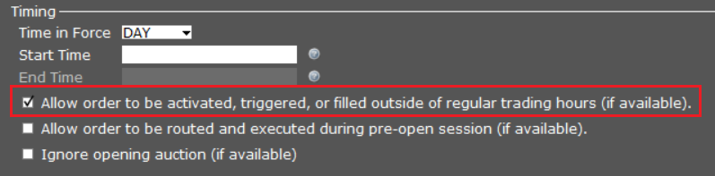

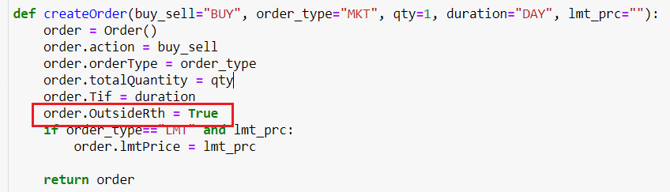

I had a second question as well…

I am starting to get comfortable with classes and inheritance in python… but I am still learning. Do you mind if we place all or most of the functions into their own class? And could they be callable as @classmethods? I’m trying to think of the best way to streamline my future use of them. If you disagree or have an idea that would be better as far as organizing them please let me know.